***Age vs Periodontitis Disease Risk***

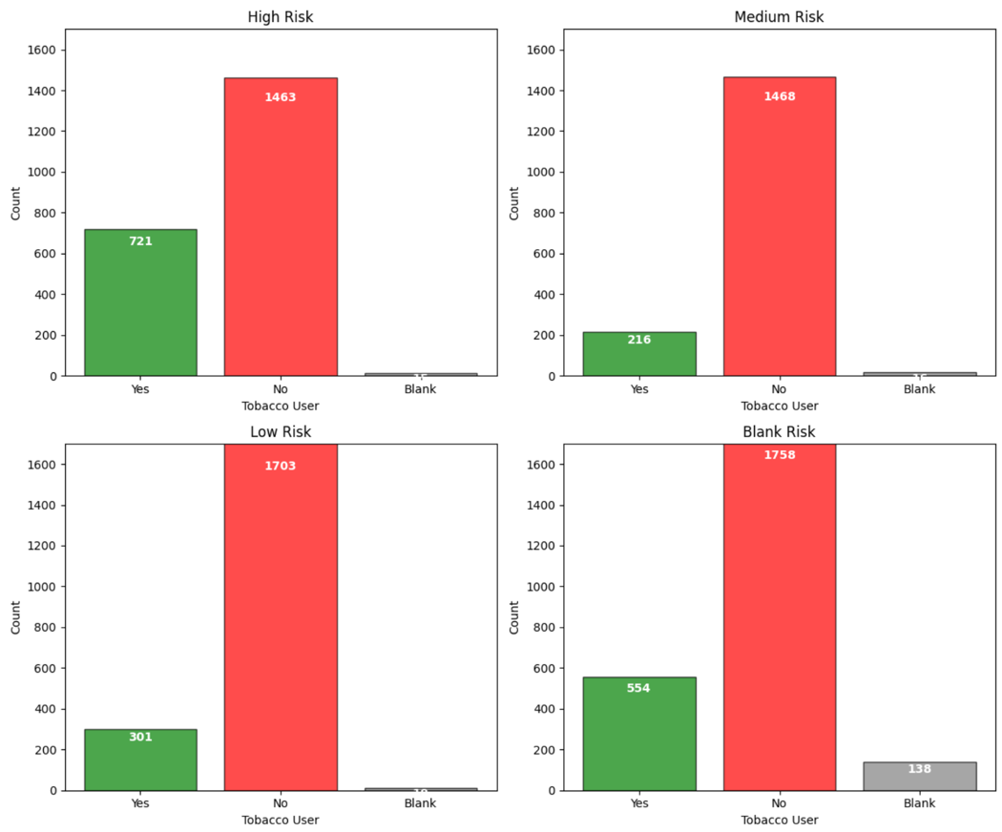***Tabacco User vs Periodontitis Disease Risk***

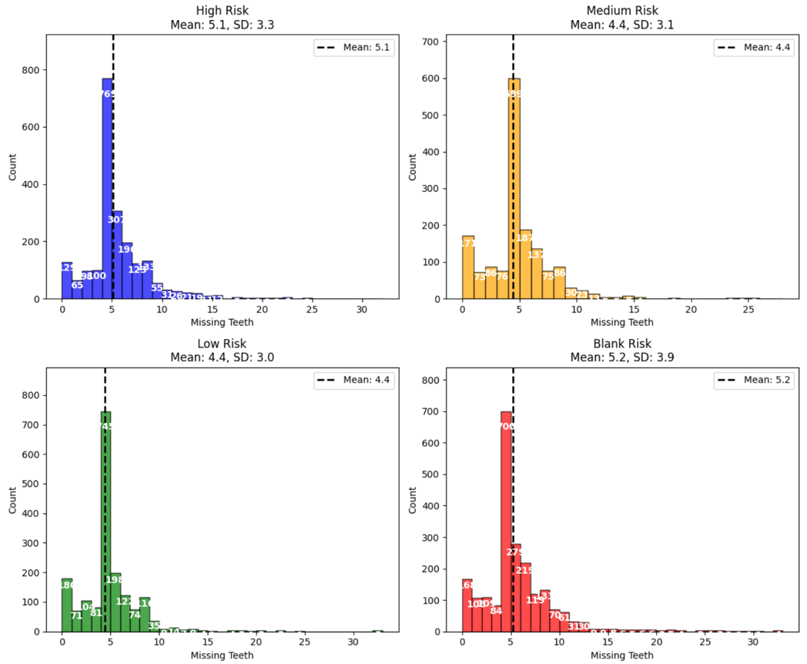***Missing Teeth vs Periodontitis Disease Risk***

***Gender vs Periodontitis Disease Risk***

Note: The percentages are normalized because there are ~1400 women in the study and ~7000 men. For each group, the percentage was calculated as:

* %_of_gender_i_in_group_j = #_of_gender_i_in_group_j / total_gender_i
* %_of_men_in_high_risk = #_of_men_in_high_risk / total_men (example)

